**LIBRARY DATABASE**

**Queries:**

**1)List the publisher details who has published more than 1 book.**

select p.name,p.address,p.phone

from publisher p,book b

where b.publisher_name=p.name

group by name

having count(8)>1;

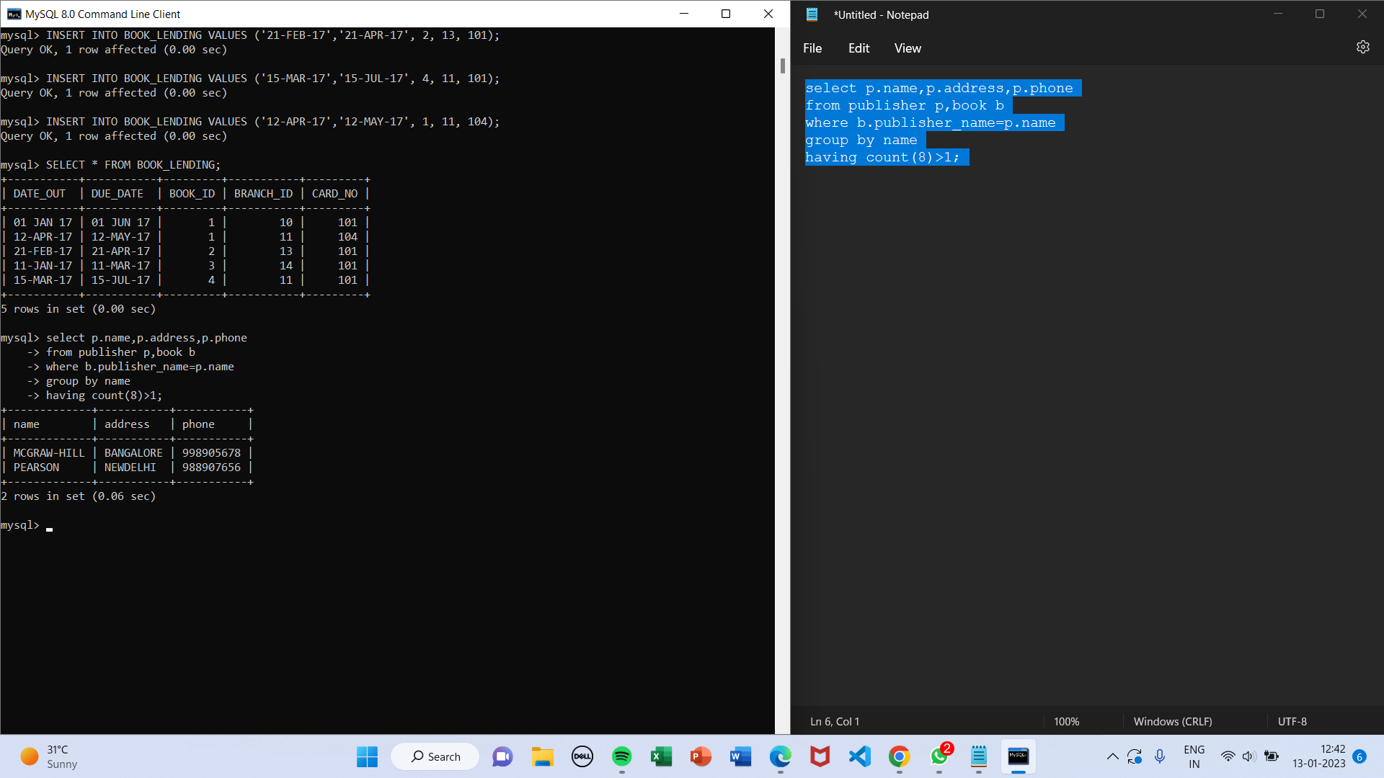

**2)List the book author where his book is available in the library.**

select x.author_name

from book_authors x,book_copies y

where x.book_id=y.book_id;

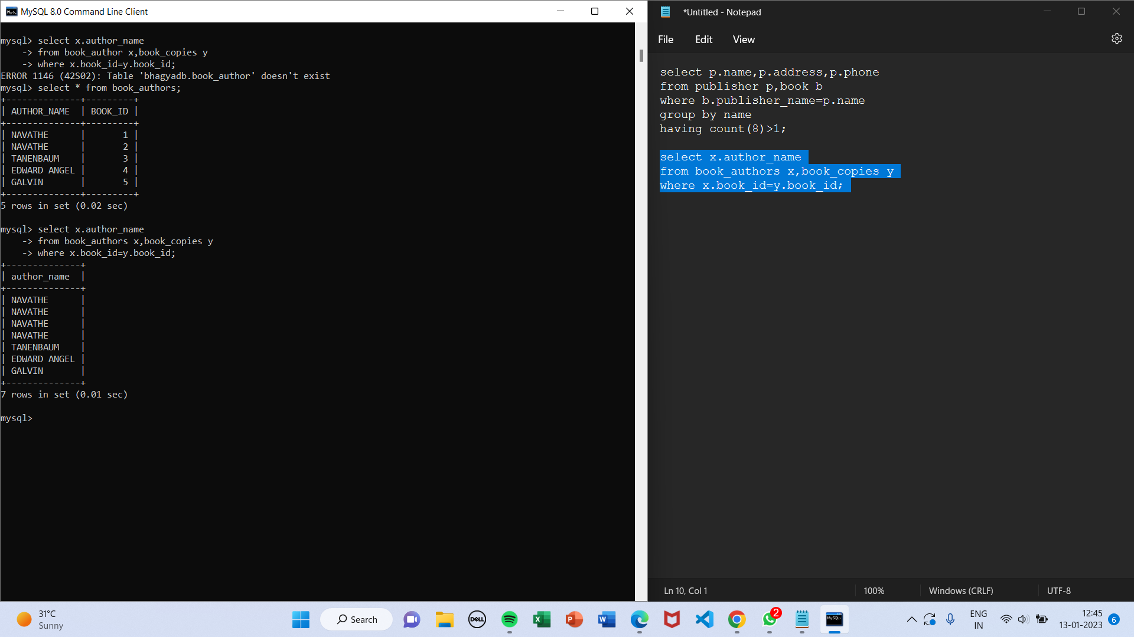

**3)List the student who has taken more than 1 book.**

select card_no

from book_lending

group by card_no

having count(*)>1;

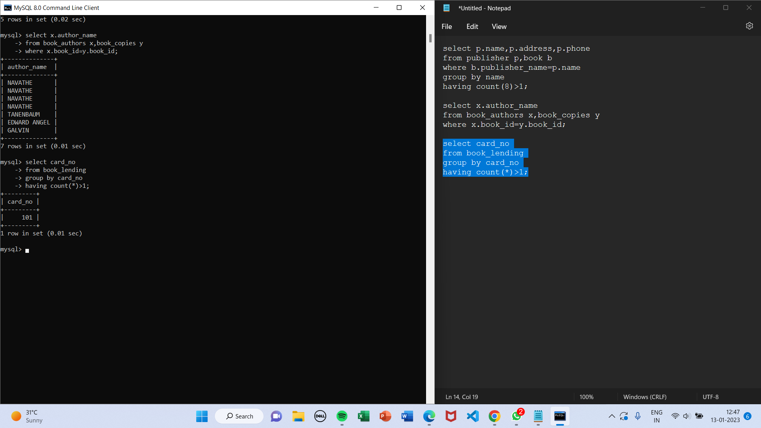

4**)Create an assertion to check minimum 1 book borrowed by a student.**

create assertion minbok

check (exists

(select card_no

from book_lending

group by card_no

having count(*)>0));

**5)List library branch containing particular book**

select x.branch_id,x.branch_name,x.address

from library_branch x,book_authors y

where x.branch_id=y.branch_id

and y.book_id=1;

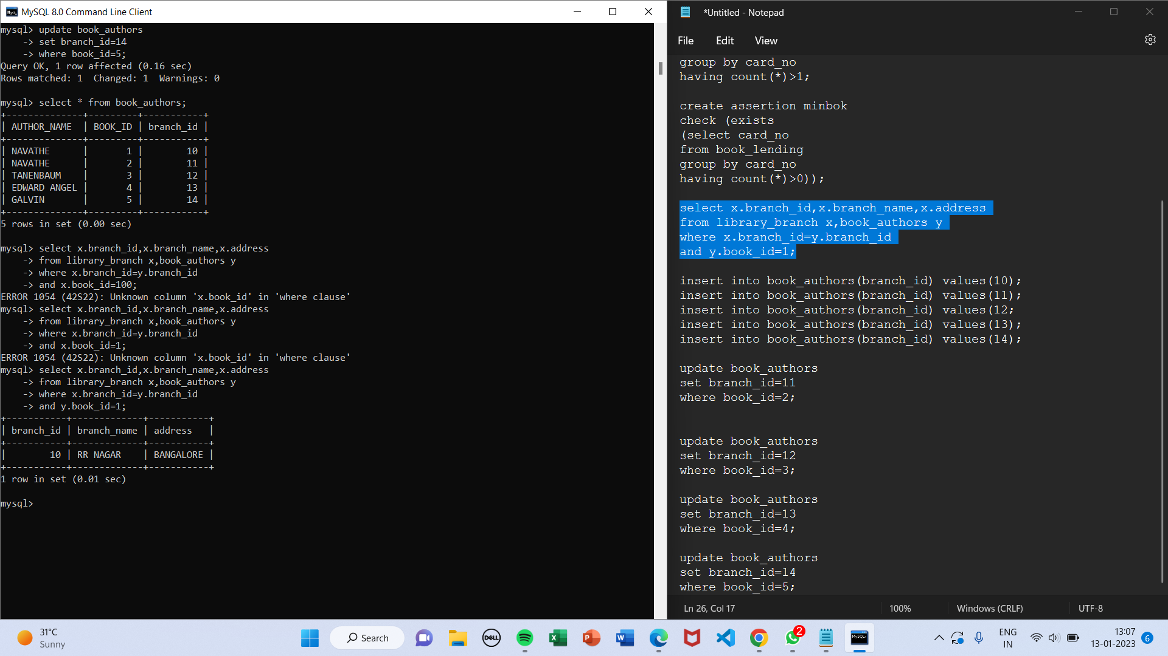

**Presented by: CSE 5A**

Babitha Rani B (1JS20CS040)

Bhagyashri Shetty H (1JS20CS043)